**Assignment 1**

* Multiple completed games: Ignore the 98 and the number beside the first guess of the new games, I just put them there so I can complete the games fast, they are removed in the code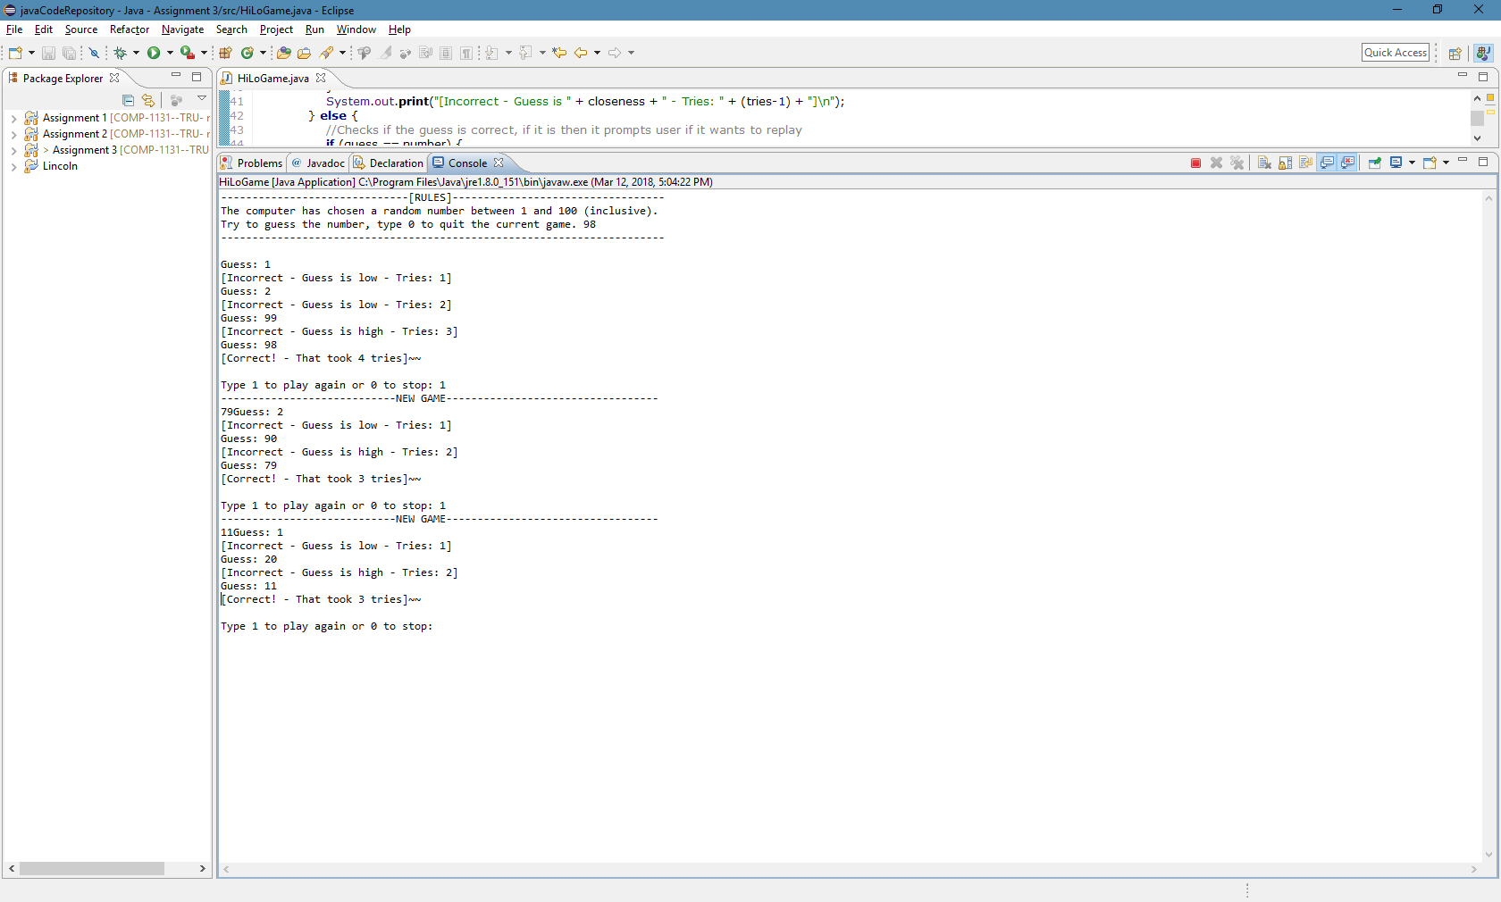
* A game quit in progress: it ask the user if it wants to play again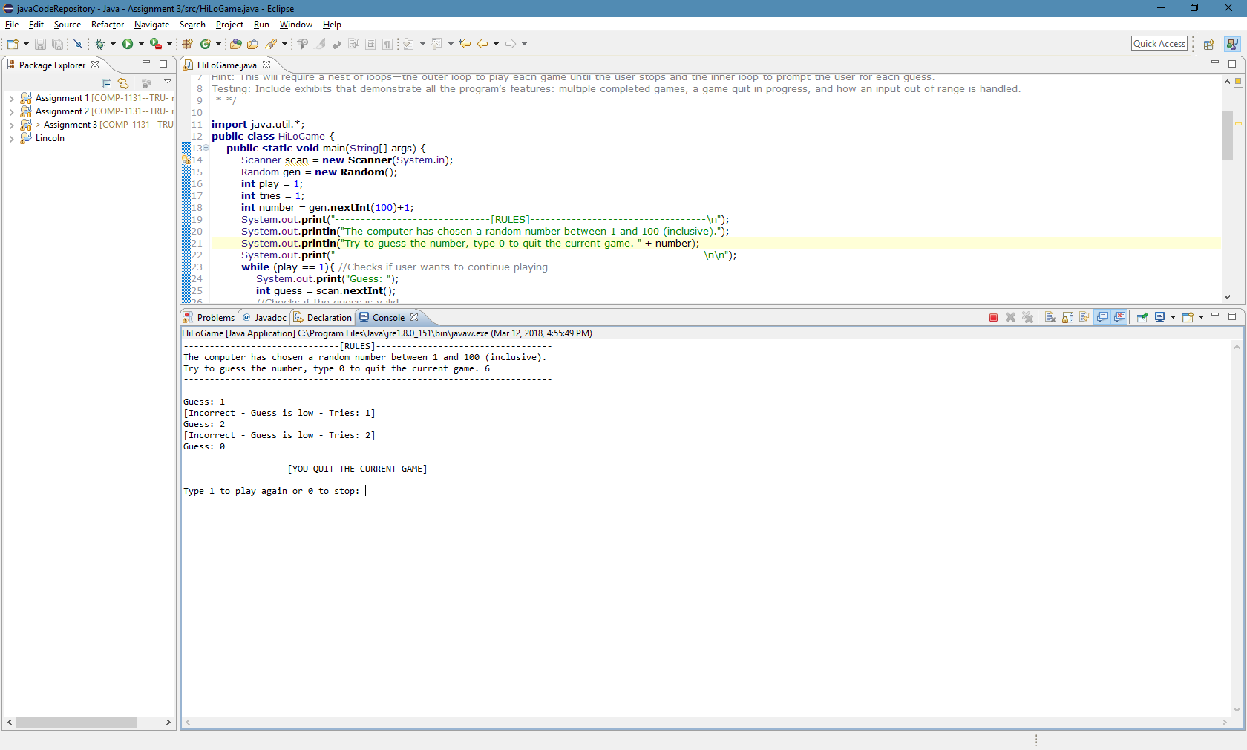
* Input out of range: It makes user repeat if input is invalid number for both guess and for if they want to play again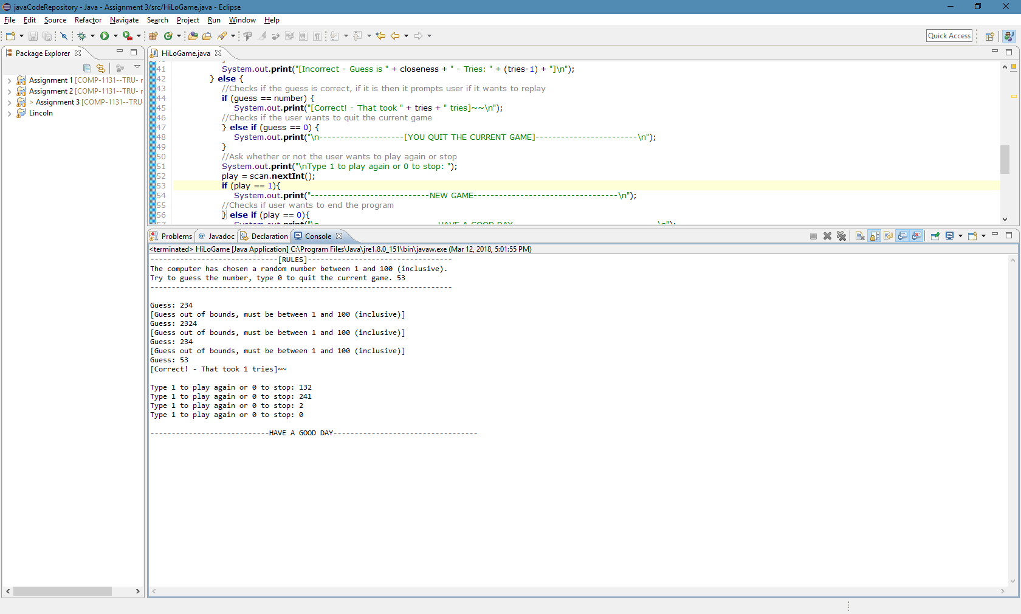

**Assignment 2**

